NODE RELIABILITY OF UNDIRECTED GRAPHS

by

Neyousha Shahisavandi

Supervisor: Dr.Jason Brown

at

Dalhousie University

Halifax, Nova Scotia

April 2018

**Table of Contents**

**Abstract . . . . . . . . . . . . . . . . . . . . . . . . . . . . . . . . . . . . . . . . . . . . . . . . . . .. . . . . . . . 3**

**Acknowledgements . . . . . . . . . . . . . . . . . . . . . . . . . . . . . . . . . . . . . . . . . . . . . . . . . . 4**

**Chapter 1…..Introduction . . . . . . . . . . . . . . . . . . . . . . . . . . . . . . . . . . . . . . . . . . . ..5**

**1.1 History of Graphs. . . . . . . . . . . . . . . . . . . . . . . . . . . . . . . . . . . . . . . . . . . . . . . ..6**

**1.2 Background. . . . . . . . . . . . . . . . . . . . . . . . . . . . . . . . . . . . . . . . . . . . . . . . . . . . . 11**

**Chapter 2. . . . . . . . . . . . . . . . . . . . . . . . . . . . . . . . . . . . . . . . . . . . . . . . . . . . . . . . …13**

**2.1 Node reliability. . . . . . . . . . . . . . . . . . . . . . . . . . . . . . . . . . . . . . . . . . . . . . . . . . 13**

**2.2 Roots of the Node reliability polynomial. . . . . . . . . . . . . . . . . . . . . . . . . . . . ...15**

**2.3 Inflection Points and Monotonicity . . . . . . . . . . . . . . . . . . . . . . . . . . . . . . . . . 18**

**Chapter 3. . . . . . . . . . . . . . . . . . . . . . . . . . . . . . . . . . . . . . . . . . . . . . . . . . . . . . . . . .20**

**3.1 A Search to Find the Optimal Graph . . . . . . . . . . . . . . . . . . . . . . . . . . . . . . . . 20**

**3.2 A Brief Look at Nearly Complete Graphs. . . . . . . . . . . . . . . . . . . . . . . . . . . . 22**

**3.1 Conclusion. . . . . . . . . . . . . . . . . . . . . . . . . . . . . . . . . . . . . . . . . . . . . . . . . . . . . . 27**

**3.2 Open Questions. . . . . . . . . . . . . . . . . . . . . . . . . . . . . . . . . . . . . . . . . . . . . . . . . . .28**

**Abstract:**

Graph theory is one of the most applied mathematical subjects in the real world. From scheduling exams at the universities to find the shortest way when using a GPS. Modern graph theory was first introduced by Euler. However, graph representation and family trees go back to ancient Egypt and the middle age era respectively. There are many interesting theories driven from the initial idea of graph theory. For instance, in 1976 it was shown that any planar graphs, like the world map, can be colored with at most four colors. This theorem is known as the Four Colors Theorem. Another interesting subject which is explored in this paper is the node reliability of undirected graphs. Undirected graphs with the same number of vertices were drawn and their

node reliability polynomials are explored for probabilities 0 to 1. Also, an attempt is made to find the most efficient graph configuration for a certain number of vertices.  The obtained results are rather counter-intuitive and interesting to discuss.

**Acknowledgments**

**First, I would like to thank Dr.Brown, my supervisor, who is very patient, understanding and helpful with students. I also want to thank Dr.Pronk for helping me through the honours process and, Dr.Janssen who made me interested in graph theory. I would like to thank the Chase building staff and all who helped me through my research. Finally, I would like to thank my family and my cat, who made my home the best place for thinking.**

**Chapter 1**

**Introduction**

As a freshman attending university, I always hoped that I would have two exams at the same time, so one would be rescheduled to a later day. After getting to study graph theory and its applications, I have discovered this event is not likely to happen. Graph theory is the study of connections between a series of vertices. The vertices are called *nodes* and an *edge* connects two nodes together. This may seem to be very primary and simple to understand, but graph theory involves plenty of complex analysis and algebra. Graph theory has numerous daily applications such as ranking hyperlinks, finding the shortest way when using GPS (map matching), and representing links between different stations. [1] Molecular structures are also represented by graphs. The bonds are the edges and the atoms are nodes. Drawings from 1784 show that chemists used graphs to represent crystals in 3D. [2]

Graph theory also has application in modeling human brain network. Neurophysiologists have started to study the human brain by modeling it as a complex series of network. A brain graph theory network represents the real structure of the human brain. In this method, the regions are described as vertices and anatomical links are defined as the connection between the vertices. Also, researchers are able to map brain regions to different brain functions by conducting various tests. Data are collected by performing EGG which is a non-invasive procedure. This method also helps with understanding brain dysfunctions such as dementia. [3]

Studying the theories related to graphs can give us ideas to solve everyday problems as well. For instance, the Four Color Theorem (FCT). For many years, mathematicians looked for a way to find a general rule for obtaining good coloring for graphs. *Good coloring* refers to a way of coloring a graph such that no adjacent vertices have the same color. In 1976, Appel and Haken discovered that any planar graph can be colored with at most four colors such that no adjacent vertices have the same color.[4]A *planer graph* is a graph which can be drawn in the plane such that no two edges intersect except at a vertex. [5] An example of a planar graph is the world map. Nodes can be the countries and edges represent boundaries. The FCT was initially based on a large data analyzed by computers. Later the theorem was proved with mathematical induction as well. [4]

Overall, the study of graphs requires long hours of dedication due to its highly visual nature. The same graph can be drawn with so many configurations such that one cannot realize they are exactly the same; these graphs are *isomorphic* to each other.

**1.1 History of Graphs**

To understand the development of graph theory, we must start by studying its history. The application of graph theory goes back to ancient Egypt. The Mill board game was carved out on roof slabs of Ramses I temple. This is the first direct application of graph theory. Visual representation of the game and drawings are found from the 13th century. Another usual application of the graph theory is the idea of genealogy trees. There are many ways to draw edges between a series of nodes. If a graph does not contain a cycle, then it is called a *tree*. Family genealogies are represented by trees. This practice goes back to at least to the 11th century. This is a very usual tradition in families especially when they are decedents of a religious figure. Another use of graphs in the middle ages was brainstorming and representing ideas. A method called *square of opposition* was used to teach math and logic. The drawn square helped pupils to recall their knowledge. Figure 1 is a small sample of the square of opposition from the 14th century. Nodes represent logical prepositions and edges are the relations between them. [2]

The idea of the modern graph theory first was introduced by Leonhard Euler in 1736 in his famous Königsberg bridges paper. The problem of Königsberg was introduced to Euler by one of his friends, Karl Ehler. Königsberg , located in Prussia, was crossed by the Preger river.

Figure 1

During that era, the mainland was connected to two Islands via seven bridges. Citizens of this city were wondering if they could cross all the bridges exactly once. Figure 2 is a layout of the city in 1736.

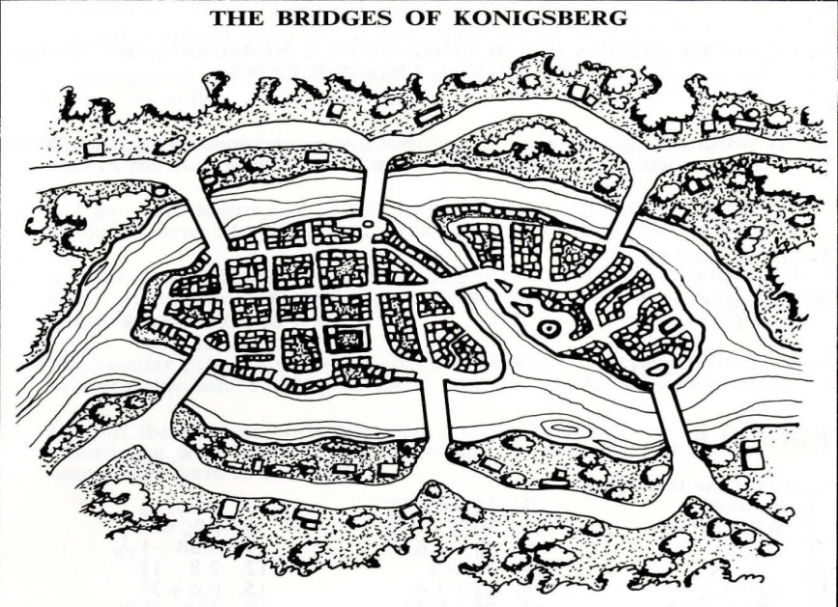

Figure 2

By trying out different paths, we can see that it is not possible to cross all bridges exactly once. Even though Euler found this problem to be trivial at first, but later he decided to study the problem and find an answer for the general case. Euler simplified the problem further by labeling the landmasses with capital letters and bridges with small letters. This was a new perspective in modeling geometric problems in his era. Euler proved that is not possible to cross all the bridges only once because all the landmasses have an odd number of bridges. In modern graph theory, the *degree* of a node is number of edges connected to it. This is exactly the idea of number of bridges. However, Euler never used dots and lines to represent the model. In his Königsberg paper, he concludes that if there exist more than two lands with an odd number of bridges, then there is no possible way to cross each bridge exactly once. Then, he claimed that if the number of bridges is odd for exactly two lands, then one can cross all the bridges once if they start in one of the two landmasses.  In the end, Euler claims that if the numbers of lands are even, then one can start from any region and complete their journey by crossing each bridge exactly once. In modern mathematics, the *Eulerian path*, which is a path containing every edge of a graph only once, is named after Euler’s contribution to the problem. Euler used a very simple mathematics in his paper to solve this problem. He describes that number of the appearance of a landmass with an odd number of bridges must be equal to

and then the sum of the appearance of all lands must be equal to  
 *number of all bridges+1*

Based on the Königsberg map in Figure 2, Table 1 is prepared. By doing a simple addition we can see that sum of all bridges +1 equals to 8 while sum of the appearances equals to 9. Since there is inequality is formed, there is no possibility of crossing all the bridges only once. [7]

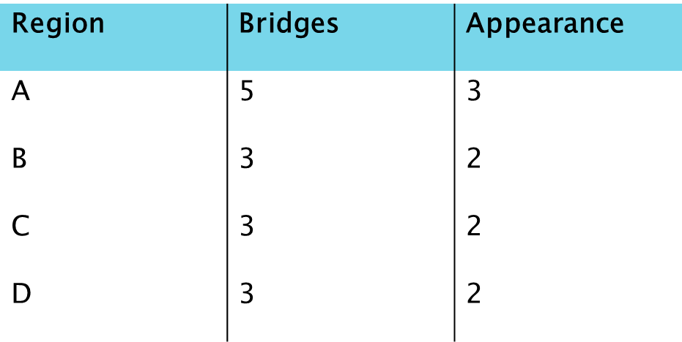

Table 1

Euler had lack of interest in visualizing the problem in term of dots and edges. Evidence suggests Euler’s familiarity with *geometria situs*, an old term for topology, prevented him to use figures and models so that all the mathematical assumptions would be solely based on imagination.[2] In 1759, Euler published a paper “Knight’s Tour” which explored the sequences of moves that a knight can take to pass every square of the checkerboard exactly once and get back to the starting position. Later in 1771 Vandermonde clarifies the case by drawing graphs (Figure 3). In figure 3 the dots are the chessboard squares and edges are the allowed moves for the knight. Many years after the Königsberg paper, in 1892, W.W. Rouse Bell modeled the Königsberg bridges similar to modern graphs. In figure 4, the left side is Euler’s representation of the Königsberg problem and the right side is Bell’s graph model. Bell used edges to represent the bridges and used nodes to represent landmasses. [2]



Figure3



Figure 4

In 1847, Listing introduced a graph representation, figure5, which could be drawn in a single stroke. Later in 1857, Arthur Cayley, who is a well-known mathematician in algebra field, used labeled trees in one of his paper. Figure 6 is an example of these trees.[2] Nowadays, the representations of graphs are similar to Cayley’s and Bell’s model. However, as mathematicians continue to look at more complicated graphs and theories, the graphs are now mass generated by programs like Maple to facilitate their study.[2]

.

Figure 5



Figure 6

**1.2 Background**

Now that history of graphs is clear, we may proceed to review some of the fundamental definitions in graph theory. A graph is *simple* when it contains no loop. A graph said to be *connected* if any of the two nodes in the graph are joined by a path. The *order* of a graph G is number of its vertices denoted by *v(G)*, and the *size* is the number of its edges denotes as *e(G).* A *(n,m) graph* represents a graph with n vertices and m edges. A graph G is *connected* if any of the two vertices are connected by a path. Two nodes are *adjacent* if they are connected by an edge. A *complete* graph with *n* vertices, denoted by *Kn,* has all the possible edges. A cycle, *Cn*, is a closed walk from *v0v1,v1v2…, vnv1* where all the *vi* are distinct. A *bipartite* graph has no odd cycles. A *chordal* graph happens when two non-adjacent vertices in a cycle are joined by an edge. A *star* graph G with n vertices has only one vertex with degree of *n-1* and all other vertices with degree of *1.* [5]

**Chapter 2**

**2.1 Node reliability**

In this research, it was assumed that all edges of a graph *G* are always working, and nodes of *G* are working with a probability of. The *node reliability*, denoted as NRel(G;p), is the probability that graph *G* has all its working nodes connected together. Here is a formal definition of node reliability taken from “*The Shape of Node Reliability”* by Brown and Mol [6]:

Definition 2.1

Let G be a network consisting of n nodes each operates independently with probability p∈ [0,1],then the node reliability of G, Nrel(G;P), is the probability that at least one node is operational and the operational nodes can are able to communicated in the generated induced sub graph.

From definition 2.1, it can be implied that edges always are working if their nodes are working; a graph is working if the working nodes are connected, and if the graph is working, at least one node is up and working. The general formula for node reliability is:

**(2.2)**

Where *c*k is the number of connected sets with order *k∈(1,2,..,n)*. In another word, it is the coefficient of connected sets made when we have *k* vertices working.[8]The the general formula for a complete graph , *Kn*, is :

**(2.3)**

*Proof.* Since nodes of a *Kn* graph are all adjacent, if at least one node is working, then the graph is working and connected. Thus, the only case which is not working is all nodes are down which is equal to **(2.3)**. [9]

The node reliability for a Complete Bipartite Graph, *Kn,n*, can be represented as:

**(2.4)**

**Example 2.5**

To gain a better understanding of node reliability, let us calculate the node reliability of a chordal graph (Figure 7) with 5 nodes and 6 edges by hand.

*Solution.*

*Case 1: suppose 1 node is only working, then we have 5 nodes to choose from. Then exactly n-1 nodes are not working.*

*Case 2: Suppose 2 of the nodes are working, then we have 10 combinations of nodes. However, 3 of the combinations make a disconnected graph, such as when n1 and n4 are the only working vertices. Excluding these cases, then we have 7cases which exactly 2 vertices are working and 3 are not.*

*Case 3: similar to case2. The only change is from the 10 possible cases, only one is not working. Thus, there are exactly 9 cases which 3 nodes are up and 2 are down.*

*Case 4: There are 5 combinations of 4 nodes working and exactly 1 is not.*

*Case 5: There is only one case which all nodes are working.*

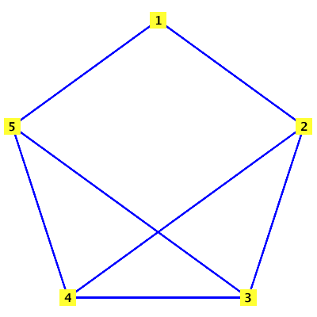

Figure 7

*Combining all these cases together, we get the following result:*

**2.2 Roots of the Node reliability polynomial**

The first method to visualize graph behavior is to find the roots of its polynomials. In this case, we are looking for the roots of the node reliability. A root of the node reliability polynomial of a graph is called *a node reliability root*.Since *p∈[0,1]*, roots out of this range is disregarded. When the probability of nodes working is zero, we can imply the node reliability polynomial is zero as well. Thus, zero is always a trivial root of node reliability polynomial. When *p∈(0,1),* according to the general formula (2.2), we always have positive numbers for the node reliability. The reasoning for this statement is simple. First, *(1-p)* and *p* are always positive. Second, the coefficient *ck* must be at least 0, because the number of a non-working graph in a certain order cannot be greater than number of the subsets of that order. Therefore, *NRel(G;p)>0 for p∈(0,1) .* As a result, there is no point in further exploring for roots in this interval. However, it is important to note that node reliability roots are unbounded and are large out of this interval. It has been proven that for arbitrary large n, the polynomial nRel(C2n+1; p) has a real root in (2n2 − 1, 2n2). [9]

It is very simple to understand the meaning of real roots. For example for node reliability polynomial, it means the probability of having a connected graph is zero at its roots. But how about the case which roots are not real? Is there any meaning to complex roots of node reliability polynomial of a graph? To this date, no meaning has been assigned to these roots. However, knowing the number of complex roots and finding their bounds may help to uncover more fact about the real roots. Brown and Mol [6] proved the following theorem about all node reliability polynomials.

**Theorem 2.6.** Let G be a connected graph of order n. If n ≥ 3 then NRel(G; p) has a non-real root.

**Example 2.7.** Let us look at node a reliability polynomial. We have

From the biggest degree, we know there are 5 roots. Zero is a trivial root. Thus, we are left with the other four. Graphing this polynomial gives us figure7.The x-axis represents the probability of nodes being functional and the y-axis shows the probability of the whole graph being connected. As we already know, there are no real roots in (0,1). Thus, we might have roots outside the interval. Taking the first and second derivative of the polynomial gives us:

Solving for the roots of the second derivative, we have *p≈0.42963.* Thus, there is a single point of inflection, and the graph is increasing after this point. Now, we know there are four non-real roots, or two pair of conjugates. Disregarding anything out of interval (0,1), we have two non-real roots (figure 8) .

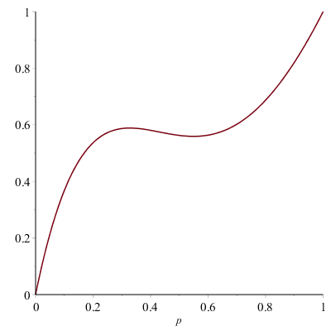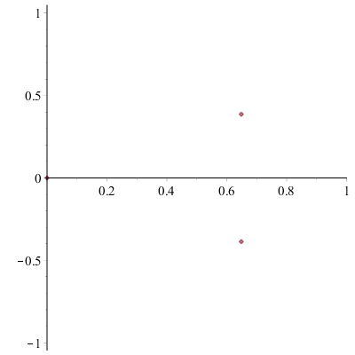

Figure 7 Figure 8

There is no bound on the complex roots of polynomials. However, the collection of node reliability roots is dense in on the complex plain. [8] A subset D of S is dense if all the non-empty open sets intersect U. For example, is dense in .(Ross)

**2.3 Inflection Points and Monotonicity**

Inflection points are points of a polynomial where the behavior of the graph changes. A *monotone* graph is always increasing, or always decreasing. One may think that a node reliability graph in the interval *(0,1)* is always increasing. However, counterintuitively, the node reliability polynomial will experience decrease as well. Imagine when there is a graph with many nodes, and the probability of them being up is 0.5. Well, there is a 50% chance that the middle node which makes the graph connected be down. Thus, the whole graph will be down. Actually, this is very usual in graphs. Figure 7 is an example of this kind of node reliability.

To explore points of inflection further, node reliability polynomials are graphed for different configuration of m edges and n vertices. Figure 9 is the series of node reliability for connected graphs with 8 vertices and 10 edges. Figure 10 is the same plot for all G(8,20). Figure 11 is all polynomials for G(8,25). As we can see, graphs start to look monotonic, as we get closer to a complete graph. The same behavior was observed for graphs with 7 and 6 vertices.

**Conjecture 2.8** The shape of node reliability polynomials for graph G with order n shifts to become monotonic, on interval p∈ (0,1), as the size of G, gets closer to a complete graph*.*

*Proof. The conjecture may be implied by the statement made by Mol (2018) on his thesis. He states that complete graphs of n≥2 vertices have no inflection point and their NRel’(Kn;p) is concave down on the interval (0,1):*

*Thus, it is reasonable to infer that as we add edges to graphs of order n, their behavior shifts to become monotonic.*

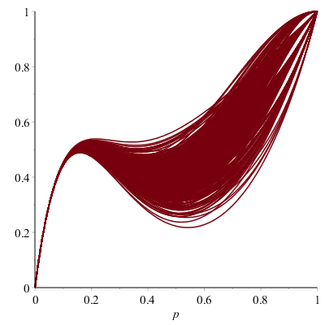

Figure 9

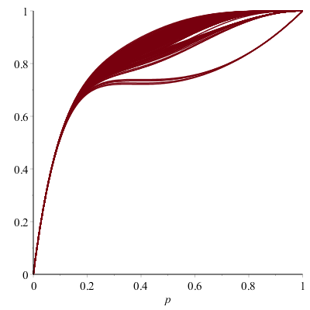

Figure 10

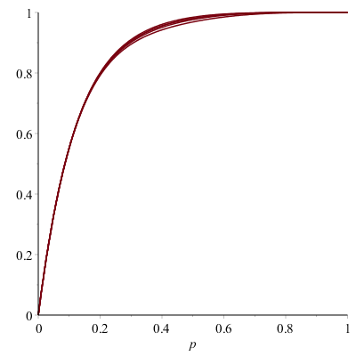

Figure 11

**Chapter 3**

**3.1 A Search to Find the Optimal Graph**

To gain a general idea about the node reliability polynomials, we must use a program which in this case is Maple. Such a computer program can plot polynomials very fast, in no time. The process is started by asking Maple to find all the connected graph of order n and size m, then draw the graph and plot its node reliability polynomial. Since less number of edges is more efficient, we started from *m=n-1* to ensure there exists a connected configuration of that size.Then, the graph which its NRel has the maximum value all the time would be the *optimal* configuration of that order and size. However, it takes a long time to compare all of these plots together. For instance, in figure 12, there are different configurations of G (6, 6). Though, there were many sets of graphs which did not have an optimal configuration.G(6,6) is one of this kind of sets; figure 13 is the plot of the set’s node reliability polynomial.

To facilitate the process further, a loop was added to the Maple code to give the optimal graph right away. This was a very helpful change in the code. The loop gave us the optimal graph configuration for n nodes and m edges. If there was not any optimal graph, the loop would give “no optimal graph” response. The code is called *Node Rel Optimal*, and can be found at Appendix A. This code is a great tool to do a survey of checking that which fraction of size relative to the complete graph of that order would give us the most optimal graph. For example, do we get the most number of optimal graphs when ? Or, is it when ? Due to lack of time, this survey was left for later research.

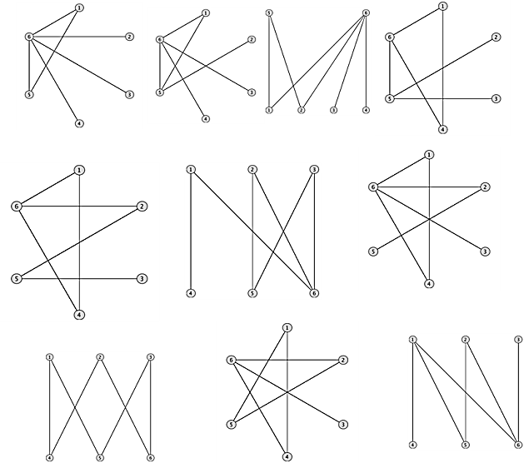

**Figure12**

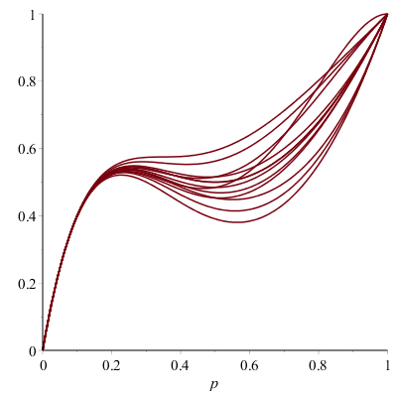

**Figure13**

Based on the results of the Node Real Optimal code, the star graph was the most optimal graph for *n-1* edges and *n* nodes. The results are consistent with the following corollary proved in [9]:

**Corollary 3.9.** Among the class of all trees on n vertices, the path Pn has the uniformly worst node reliability while the star K1,n−1 has the uniformly best node reliability.

**3.2 A Brief Look at Nearly Complete Graphs**

Since there is no general rule for finding an optimal graph, we must explore all the possibilities. One may claim that optimal graphs for G (n,m) happen when

, where *j≥2* is an arbitrary positive real number. Determining whether this statement is true or not, the following method can be used:

**Starting from for G (n,m):** First, assume there is a complete graph Kn. Then, take away two edges at random. Now, these two edges either share a vertex, or they are disjoint. Figure 14 and figure 15 are sketches of joint edges and disjoint edges respectively. The blue lines are the edges which are missing, and the dashed circles are the remaining nodes and edges. The black lines are sketched to emphasise the existing edges between the nodes.

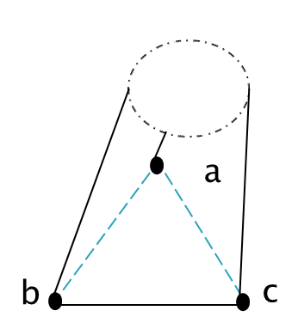Figure 14

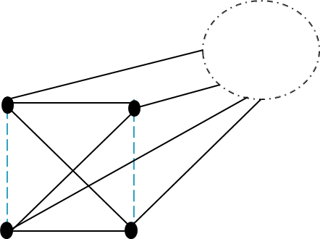

**Figure 15**

The corresponding node reliability polynomial for figure 14 is

= **(3.9)**

For this calculation, cases which made a disconnected graph were taken away from the total probability, which is 1. For example, if all the nodes are not working, then the whole graph is not working. Thus, we subtract , which is the probability of all nodes being down, from 1. Another disconnected case is when nodes a and c or, b and c are the only functional nodes. This one was also subtracted from 1. Taking away all the disconnected cases leaves us with (3.9). By applying the same procedure, NRel for figure 15 is

**(3.10)**

By doing a fast comparison, it is obvious that (3.10) is always bigger than (3.9) on (0,1) interval; the first three terms are the same, however on (3.9) there is an extra subtraction which makes it smaller than (3.10) on (0,1) interval. The result leads to the following theorem.

**Theorem 3.11.**For a graph G (n, ), the graph configuration where the two missing edges are disjoint is the optimal graph.

*Proof. Let* . *Then,*

*f(p)=*

*Since , for .*

Repeating the same procedure for three missing edges, resulted in six distinct configurations. Figure 16 shows these configurations of three missing edges.

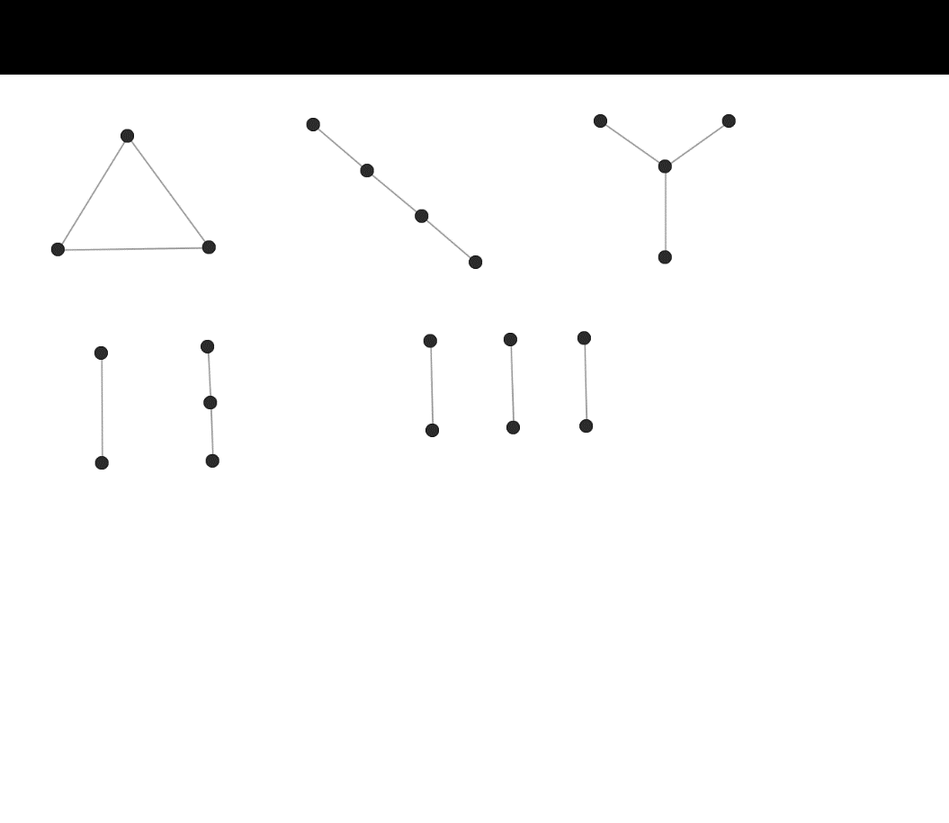

a b c

d e

Figure 16

To find the node reliability of graphs with missing edges on figure 16, we decided to use Maple. Since Maple cannot give the node reliability for an arbitrary graph with n nodes, we used the following method to find them:

We asked maple to find the node reliability of complements of graphs in Figure 16.Then subtracting each result from 1 each time, gives us the probability of disconnected complements graphs. Then, we multiplied that to *(1-p)n-j* ,where j is the number of nodes of the complement graph. This multiplication shows the probability of the whole graph being disconnected. At the end, to find the node reliability for n nodes, we subtracted the whole term from 1 again. The following example clarifies the process further.

**Example 3.12.** Consider Figure 16a and let us call this graph *a.* The complement of this graph is Figure 17. Let this graph be *a.comp .* Maple gives NRel(a.comp;p)= . Then (1-NRel(a.comp;p)) is the probability that *a.comp* is down. In order to find the total node reliability, we have to consider the probability of n*-4* nodes being down. Now, we have all possible cases of a graph with Figure 16a missing edges being disconnected. For the last step, to find the *working* cases, we subtracted the final term from 1:

NRel(Kn-a)=1-(1-p)n-4(1-NRel(a.comp;p))

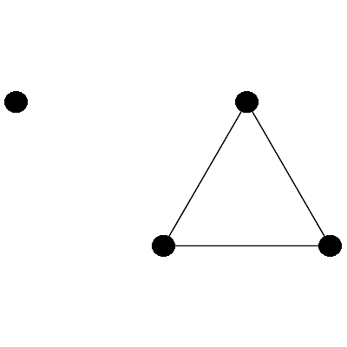

Figure17

Following the same method for the rest of the graphs, we get the following general form for 3 missing edges: *NReal(Kn-3e)= 1-(1-p)n-j(1-gn).*Where *e* denotes the missing edges, *j* denotes the number of nodes of graphs on Figure 16, and 1-gn is the node reliability of the complement graphs of Figure 16. We generalized the results further and came up with this form for graphs with 3 missing edges: *NReal(Kn-3e)=1-(1-p)n-j((1-p)m(1-gn),* where *m* is a positive power. Finally, all the node reliabilities for 3 missing edges on the interval (0,1)gives us Figure 18. The most optimal graph for 3 missing edges is when Figure 16c happens.

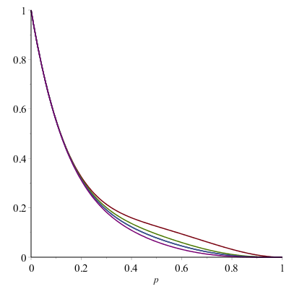  
 Figure18

**Chapter 4**

**4.1 Conclusion**

Even though graph theory applications go back as far as ancient Egypt, only small pieces of information are known about their node reliability. Complete graphs and complete bipartite graphs are the easiest graphs to study. Their node reliabilities have a general formula namely (2.3) and (2.4). Also, the shape of their reliability may be studied very easily by calculus. For example, we know there is no point of inflection, which suggests a change of behavior, in node reliability polynomial of complete graphs. However, other graphs require us to do long calculations, such as Example 2.5, to find their NRel polynomial. For bigger graphs, it takes Maple even plenty of time to calculate NRel. Also there are node reliability roots on the complex plane, and real roots outside (0,1) interval, which have no definition in the graph theory. The only assumption that we can make is node reliability polynomials look more monotonic as we add more edges.

The only guaranteed optimal graph is the star graphs and it only happens when we have a set of graphs with n nodes and m-1 edges. Otherwise, there is no other general optimal graph. The method which was introduced in section 3.2, gave the optimal graphs for 3 and 2 missing edges. However, the optimal graph for a different number of edges looks random so far. Additionally, sometimes the method does not operate. For example, there is no optimal graph for 18 edges and 7 nodes. Regardless of which process we take, there are certain graph sets which never have an optimal graph. Using either *Node Rel Optimal, or* method on section 3.2 for big graphs, takes a long time to complete. However, this is our best bet for now.

**4.2 Open Questions**

Do node reliability polynomials have characteristics like chromatic polynomials?

* We know that NRel(G;p) alternates in sign like chromatic polynomials. But, is there any meaning to the coefficients?

**Bibliography**

[1] Paul Van Dooren Université catholique de Louvain Louvain ... (n.d.). Retrieved April 17, 2018, from <http://www.bing.com/cr?IG=091827CB243B424CACCB97FFDE5D659E&CID=29C2EFB87F79653529D1E46C7ED664F2&rd=1&h=VqA_eGBvcP82960neB5hJWgxOP3NymyALfqEGScaUg&v=1&r=http://www.hamilton.ie/ollie/Downloads/Graph.pdf&p=DevEx,5068.1>

[2] Kruja, E., Marks, J., Blair, A., & Waters, R. (2002). A Short Note on the History of Graph Drawing. Graph Drawing Lecture Notes in Computer Science, 272-286. doi:10.1007/3-540-45848-4_22

[3] Vecchio, F., Miraglia, F., & Rossini, P. M. (2017). Connectome: Graph theory application in functional brain network architecture. Clinical Neurophysiology Practice, 2, 206-213. doi:10.1016/j.cnp.2017.09.003

[4] Vilfred, V. (n.d.). THE FOUR COLOR THEOREM - A NEW PROOF BY INDUCTION. Retrieved April 17, 2018, from <https://arxiv.org/pdf/1701.03511.pdf>.

[5] M., D. F., Koh, K. M., & Teo, K. (2005). Chromatic polynomials and chromaticity of graphs. New Jersey: World Scientific.

[6] Brown, J., & Mol, L. (2018, January 05). The shape of node reliability. Retrieved April 17, 2018, from <https://www.sciencedirect.com/science/article/pii/S0166218X17305590>

[7] Paoletti, T. (n.d.). Leonard Euler's Solution to the Konigsberg Bridge Problem. Retrieved April 17, 2018, from https://www.maa.org/press/periodicals/convergence/leonard-eulers-solution-to-the-konigsberg-bridge-problem

[8] Brown, J., & Mol, L. (2016). On the roots of the node reliability polynomial. Networks, 68(3), 238-246. Retrieved April 17, 2018, from <https://arxiv.org/abs/1607.08496>.

[9]Mol,S.L.(2016), On Connectedness and Graph Polynomials: A thesis on graph theory(Phd),Dalhousie University,Halifax,Canada